DriverURLInfo.robot

The below file contains driver information and URL for login and close the browser keyword for closing the browser

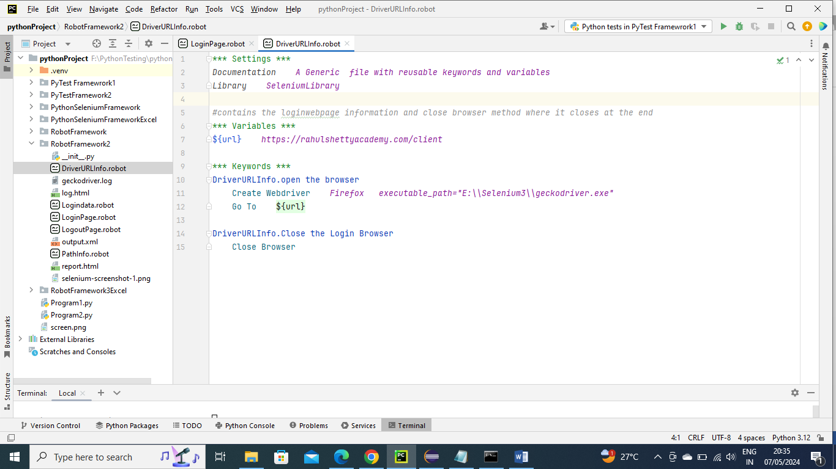

PathInfo.robot

The below file contains all the info about locators

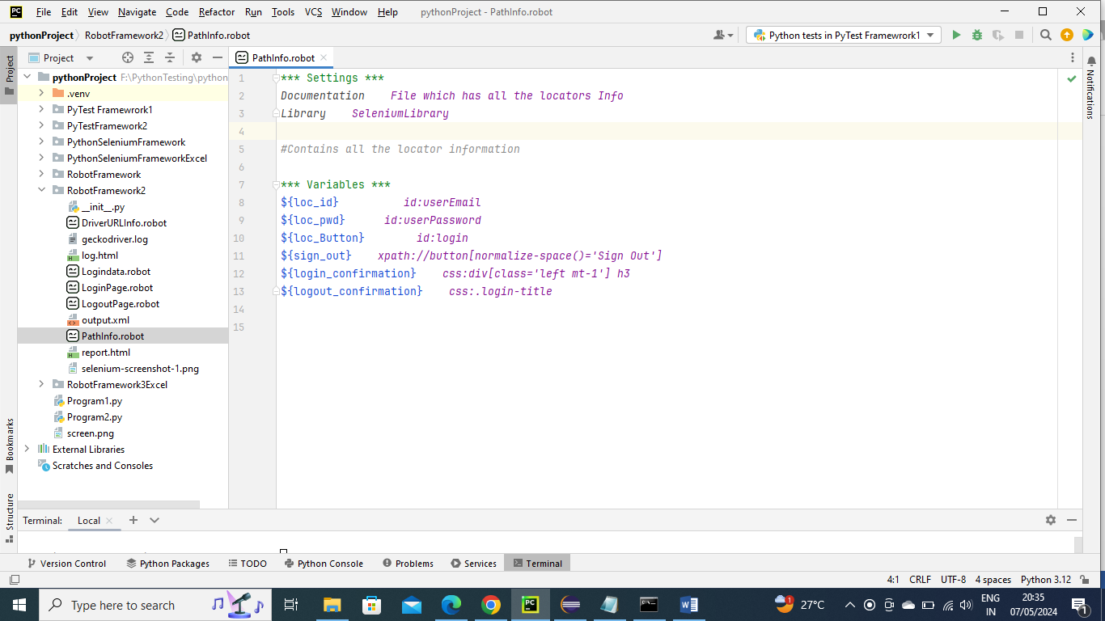

Logindata.robot

The below contains the test data for login and also this file is kind off main file you can see ”Login.validate the Login” is first keyword that’s calling from here

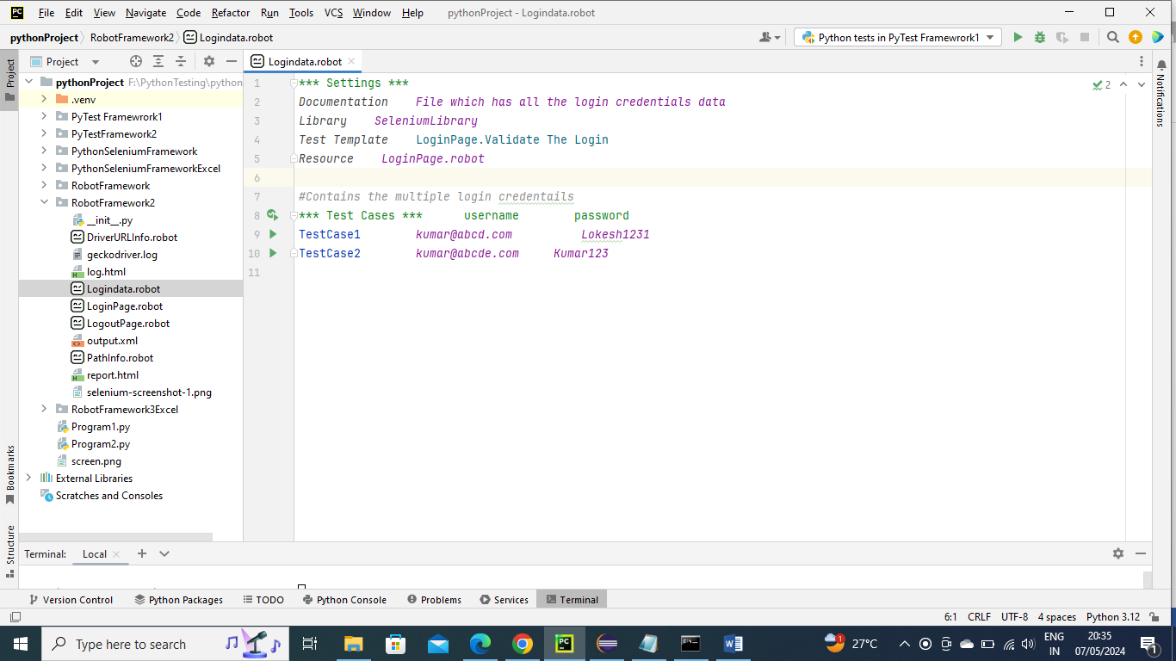

LogoutPage.robot

The below file contains the logout locator info and also verification keyword for it to complete fastly

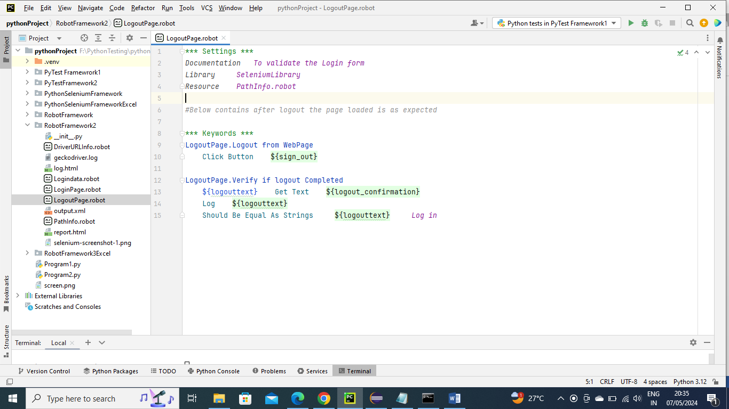

LoginPage.robot (which is also main program)

The below program Logindata.valdate the Login as called from LoginData page, here the parameters are passed normally to its keywords(or say sub keywords) and driver, URL loading and Login ,verification and Logout are performed and if any issue occurs it fails

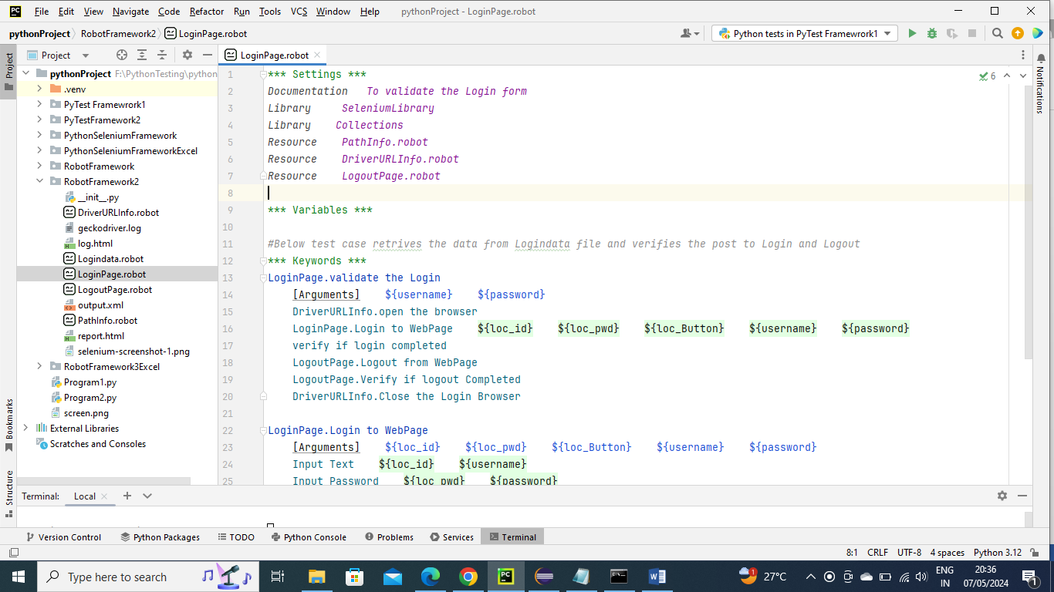

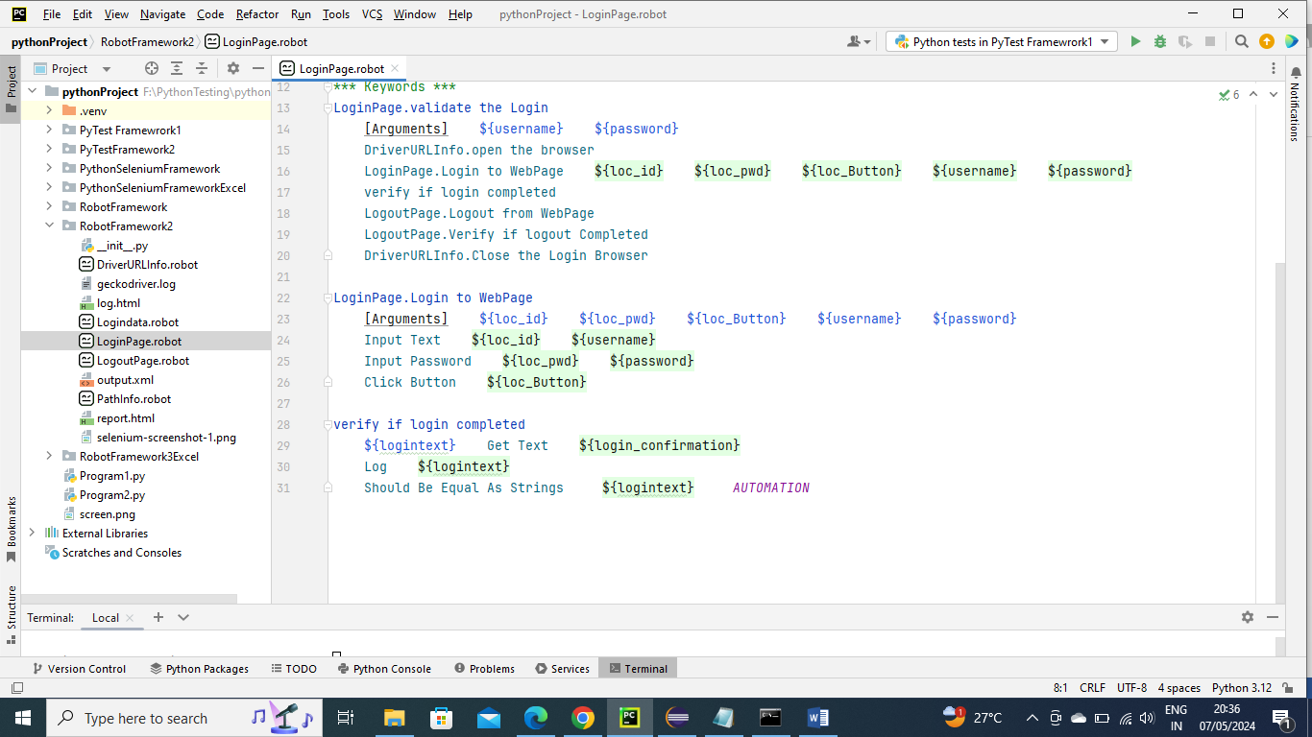

Below is the command to run the program

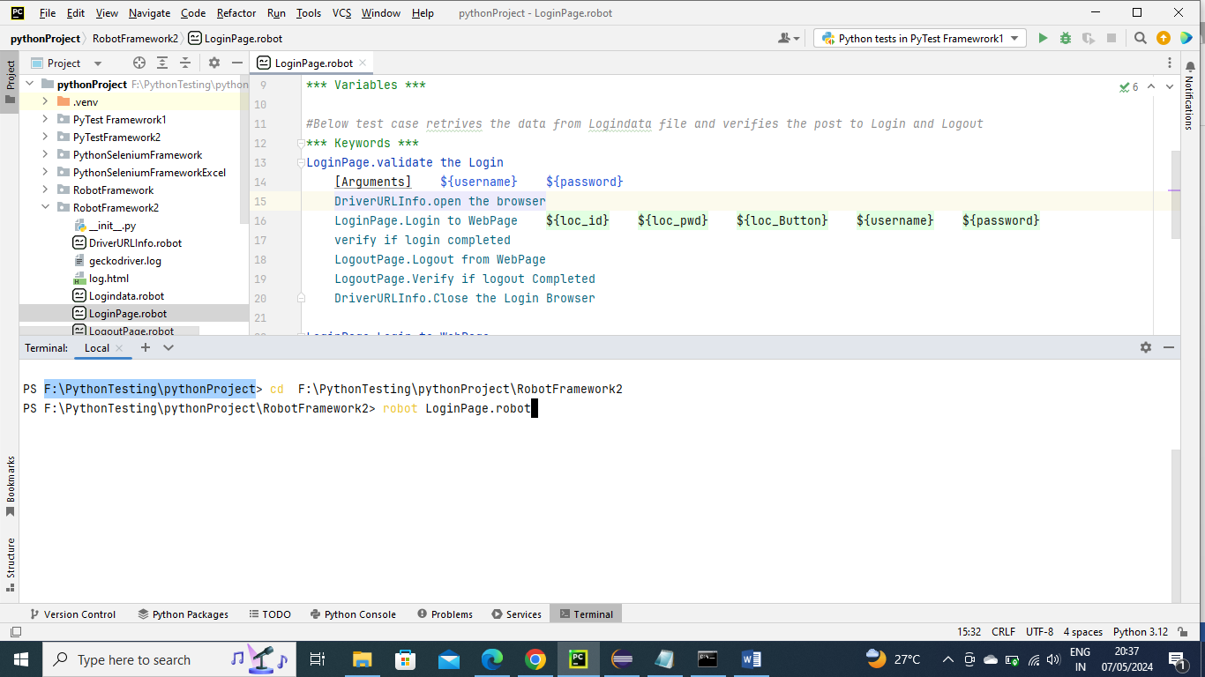

Report.html

The below report file is generated by Robot Frame work automation inbuilt directly only

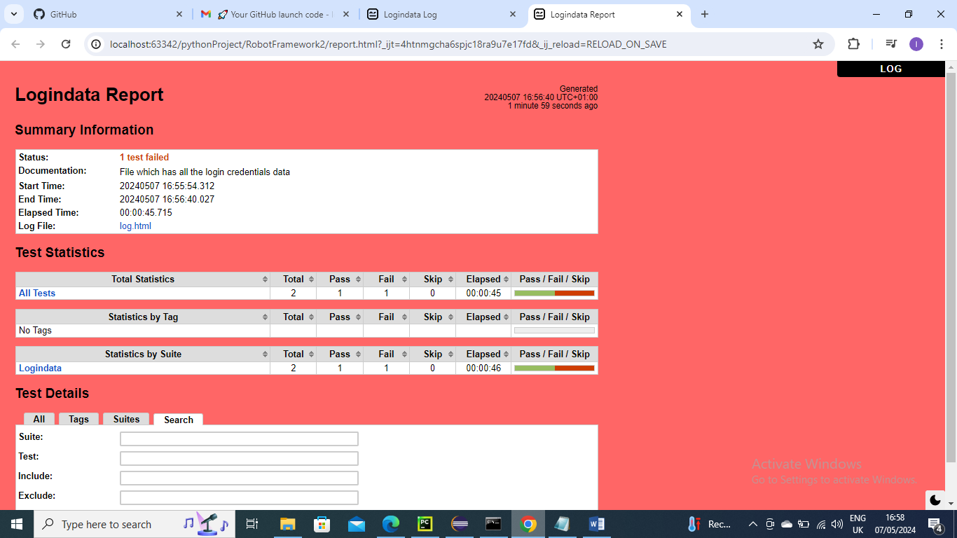

log.html

The below html file is generated by Robot Frame work automation inbuilt directly only. The screenshot is also embedded automatically

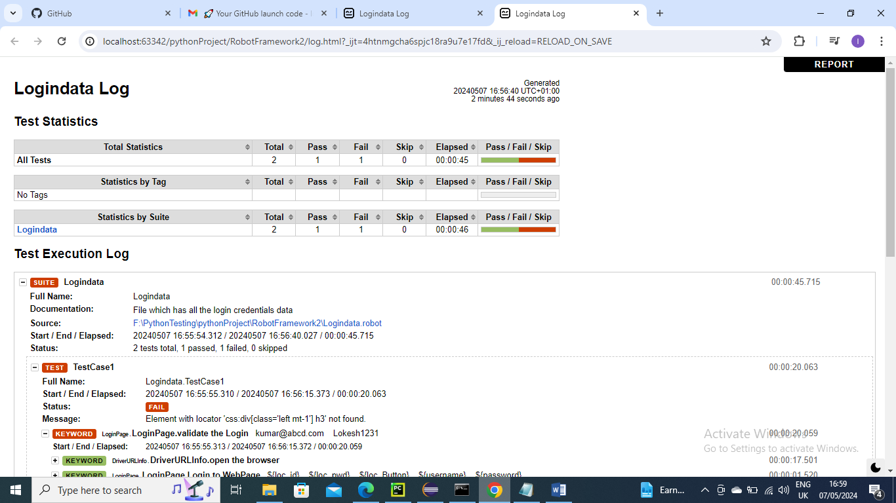

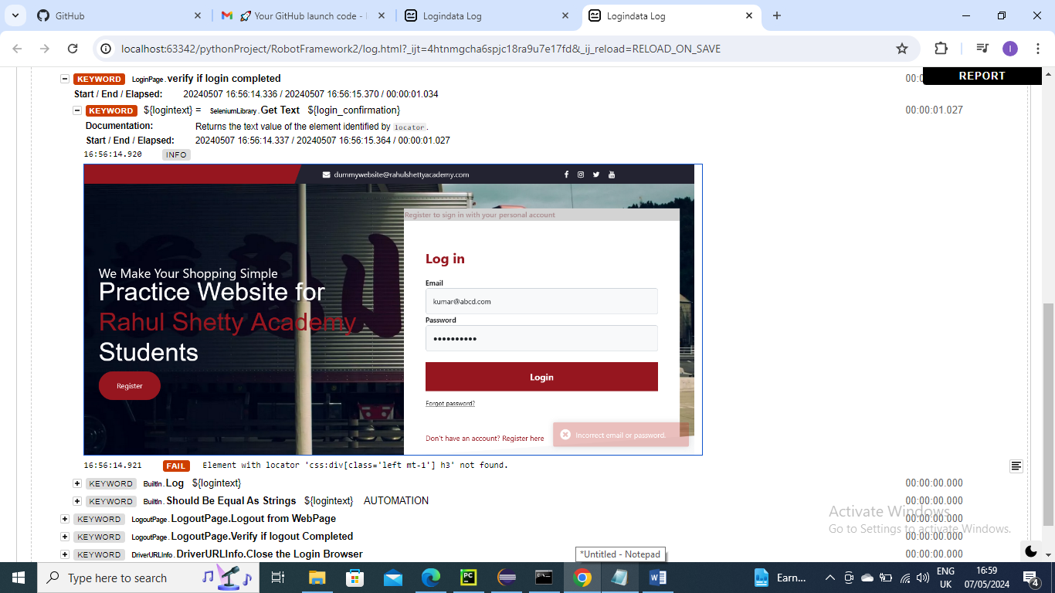

Output.xml

The below Output file is generated by Robot Frame work automation inbuilt directly only

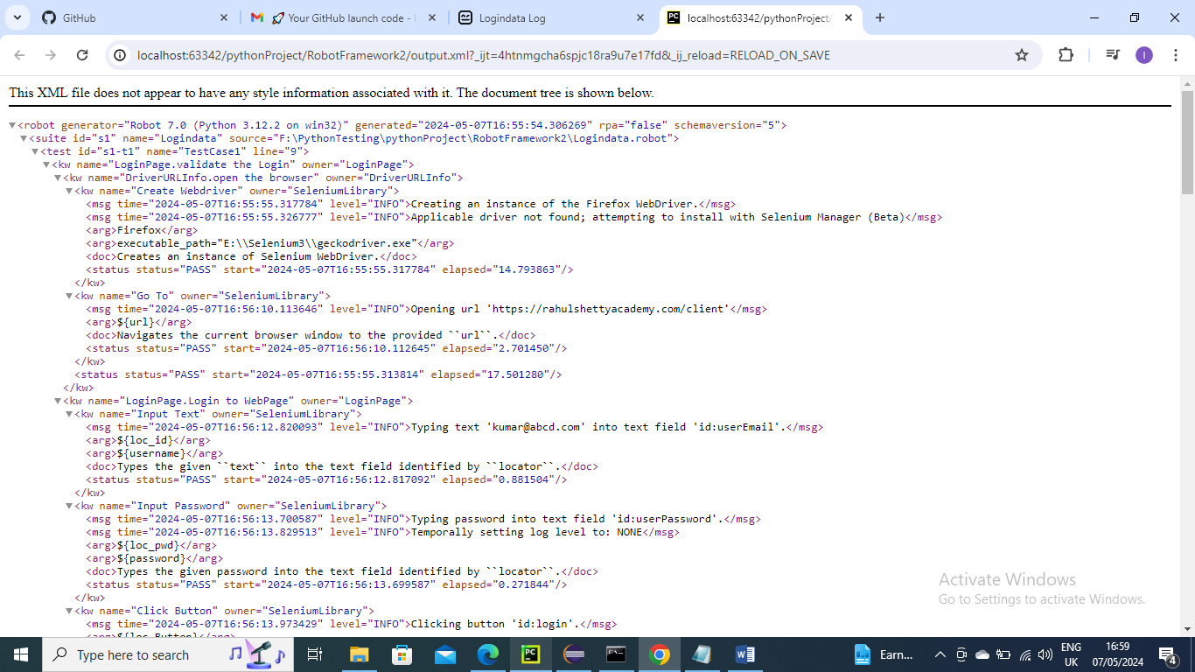

Generates screenshot at project folder as well for failed ones. Below is for reference

